UNIVERSITY OF MINNESOTA

***Duluth Campus*** *Department of Studies in Justice, Culture, and Social Change* *228 Cina Hall*

*College of Arts, Humanities, and Social Sciences*  *1123 University Drive*

*Duluth, Minnesota 55812-3306*

*E-mail: troufs@d.umn.edu*

*ZOOM:* [*https://umn.zoom.us/my/troufs*](https://umn.zoom.us/my/troufs)

*26 December 2024*

**Welcome to Anthropology 3888 Anthropology of Food: How to Access Your Canvas Class**

**We will be using the Canvas learning management system for this course.**

**You can find information about the textbook and other resources in your Canvas Syllabus.**

**During the pre-term period, you may want to familiarize yourself with the Canvas Modules for the weekly course materials.**

**How to Find and Access Your Canvas Class**

**Further instructions follow, but if you want, and your browser permits, the URL** [**https://canvas.umn.edu**](https://canvas.umn.edu/) **will take you to your Canvas home (your browser may require that you double-click).**

**Or you can enter from the UMD WebSite on any WebPage . . .**

REM: Links on screenshots are not “hot” (active)**UMD WebPage with arrow pointing to Canvas URL.
**

**If you are on one of the supporting class WebPages, simply click on the Canvas link . . .**

REM: Links on screenshots are not “hot” (active)

**Global Cultures supporting WebPage with arrow pointing to Canvas link.
**

**Your *log-in page* will then present the UM Canvas sign in prompt . . .**

REM: Links on screenshots are not “hot” (active)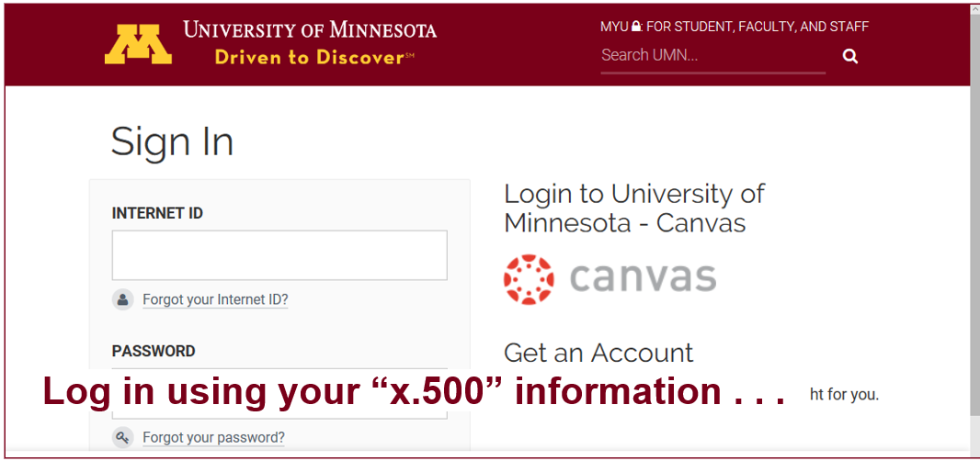

**Your sign in will then bring you to the “Duo Push” screen . . .**

REM: Links on screenshots are not “hot” (active)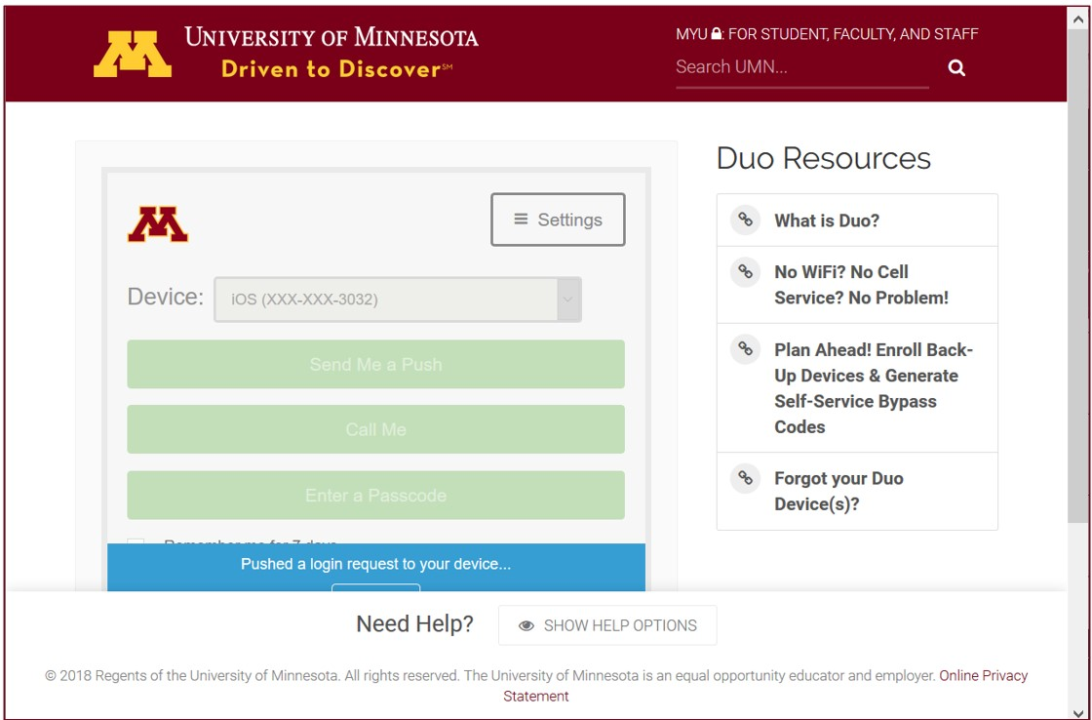

**And the “Duo Push” will send a Login Request (generally) to your phone . . .**

REM: Links on screenshots are not “hot” (active)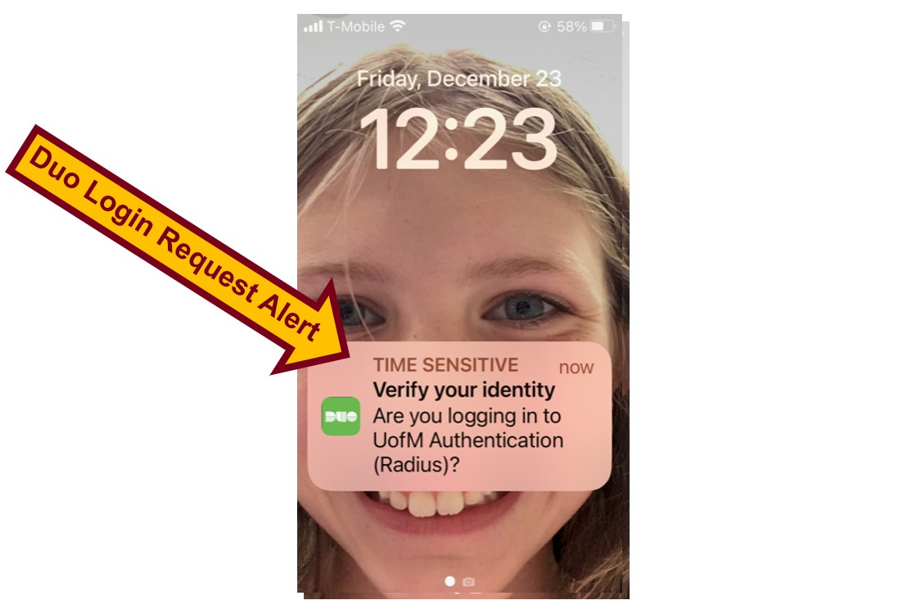

**Approve the Login Request and “Bob’s your uncle” . . . (**[**1887 Lord Salisbury?**](https://en.wikipedia.org/wiki/Bob%27s_your_uncle)**)**

REM: Links on screenshots are not “hot” (active)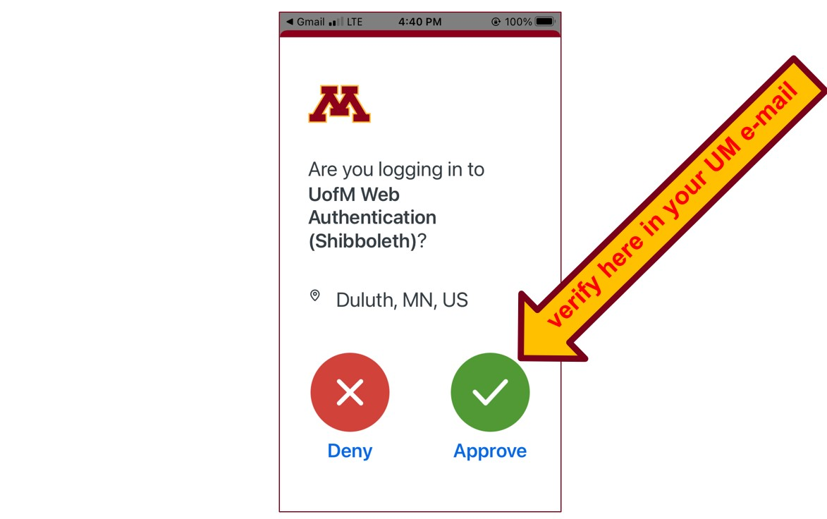

**Your Canvas “Dashboard” *on your laptop* will look something like this . . .**

REM: Links on screenshots are not “hot” (active)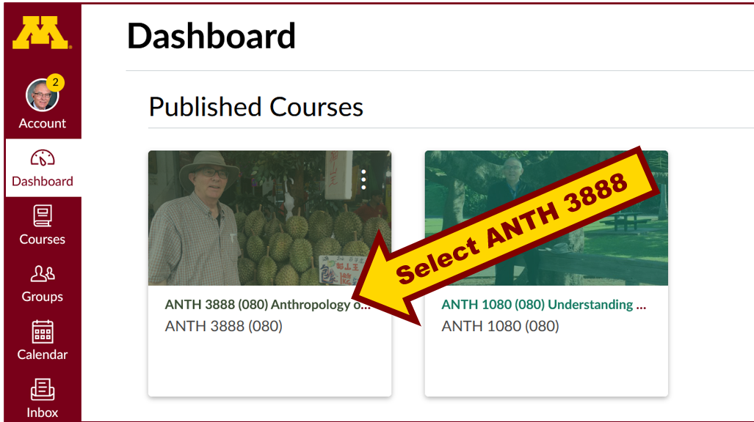

**Your Canvas “Dashboard” *on your phone* will look something like this. . .**

REM: Links on screenshots are not “hot” (active)

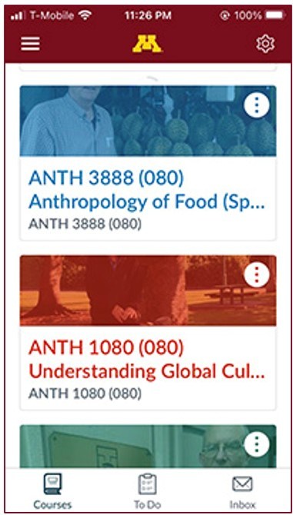

**To access your UMD Canvas site simply click on the ANTH 3888 (080) Anthropology of Food icon on a Dashboard . . . and that will take you to the Canvas Course.**

**It will take you to your Canvas “Home” screen which *on your laptop* will look something like this . . .**

REM: Links on screenshots are not “hot” (active)

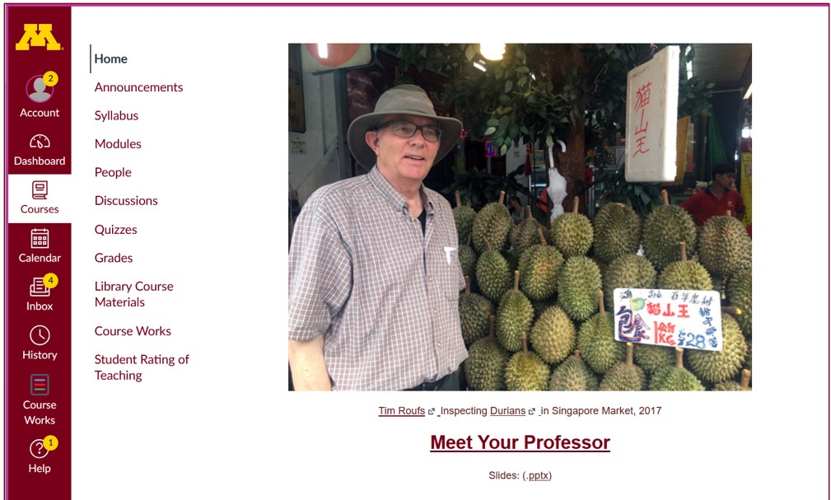

**And *on your phone your* Canvas Home screen looks something like this . . .**

REM: Links on screenshots are not “hot” (active)

**NOTE: Not all Canvas features work on *phone* apps. . . .**

**And different phone models work differently . . .**

**Where to Begin?**

**Have a look at the Syllabus . . .**

REM: Links on screenshots are not “hot” (active)

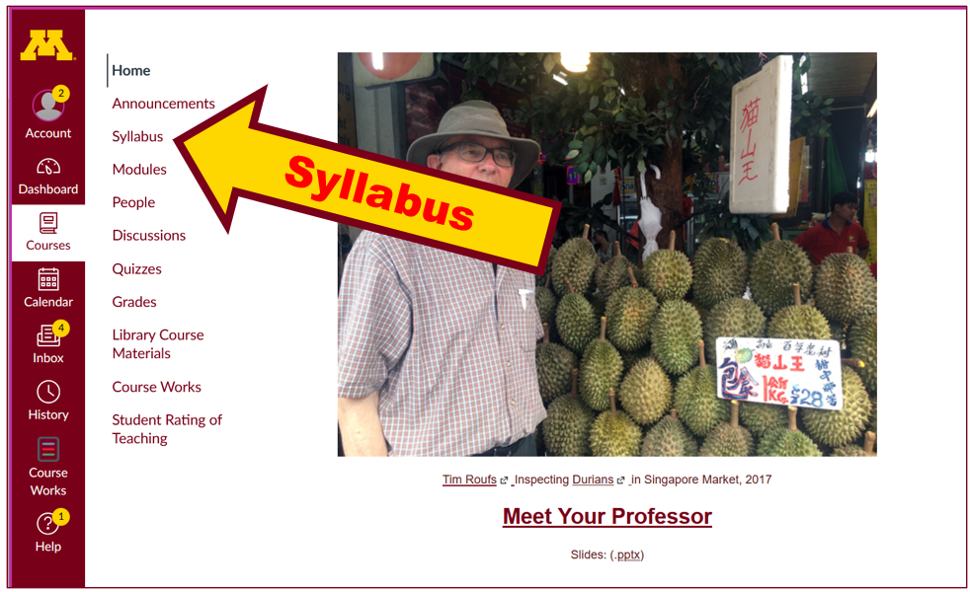

**Have a look and give it a try, and if you have any questions, or suggestions, or comments, please let us know at** [**troufs e-mail**](mailto:troufs@d.umn.edu). Small arrow icon pointing off site.

**Best Wishes,**

**Tim Roufs**

<http://www.d.umn.edu/~troufs/>

<https://umn.zoom.us/my/troufs>

<other contact information>

**P.S. If you are new to Canvas, go to the Getting Started Module, Step 2: Setting Up Your Canvas Account, and Step 3: Review the Student Services and Technology Help Information.**